Login
@startuml
actor User
participant "Web UI" as UI
participant "Authentication Service" as Auth
participant "User Service" as UserSvc

User -> UI : Enter username & password
UI -> Auth : authenticate(credentials)
Auth -> UserSvc : validateUser(credentials)
UserSvc --> Auth : validation result
Auth --> UI : JWT Token / Error
UI --> User : Show dashboard / error message
@enduml

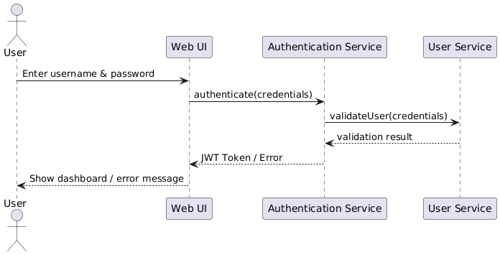

Reserve Service
@startuml
actor User
participant "Web UI" as UI
participant "Reservation Service" as Res
participant "Quota Service" as Quota
participant "Facility Service" as Facility

User -> UI : Select service & session
UI -> Res : requestReservation()
Res -> Quota : checkQuota(user)
Quota --> Res : quota status
Res -> Facility : checkCapacity(session)
Facility --> Res : capacity status
Res --> UI : reservation confirmed
UI --> User : Show reservation success
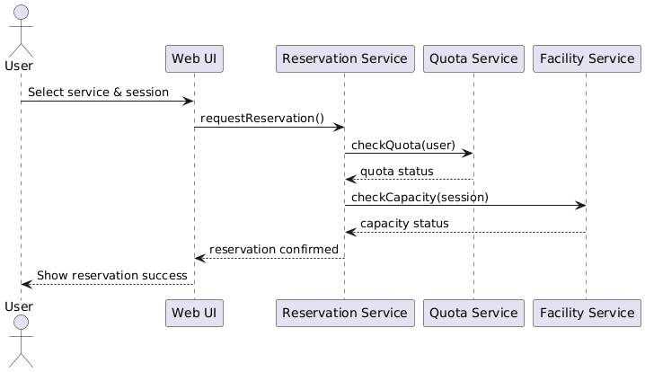
@enduml

Cancel Reservation

@startuml
actor User
participant "Web UI" as UI
participant "Reservation Service" as Res
participant "Quota Service" as Quota

User -> UI : Select reservation
UI -> Res : cancelReservation(reservationId)
Res -> Quota : restoreQuota(user)
Quota --> Res : quota restored
Res --> UI : cancellation confirmed
UI --> User : Show cancellation result
@enduml
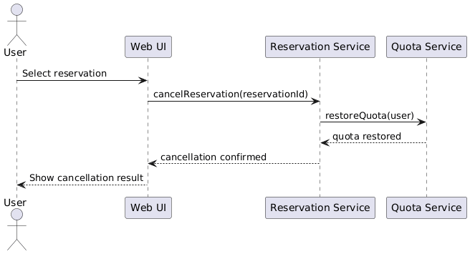
Check-in
@startuml
actor User
actor "Facility Manager" as FM
participant "Web UI" as UI
participant "Check-in Service" as Checkin
participant "User Validation Service" as Validate

User -> UI : Request check-in
UI -> Checkin : sendCheckinRequest()
Checkin -> Validate : validateUser(reservation)
Validate --> Checkin : validation result
FM -> Checkin : verifyAttendance()
Checkin --> UI : check-in success
UI --> User : Show confirmation
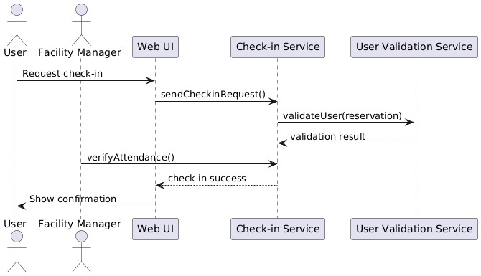
@enduml

